Experiment 1: FIND-S Algorithm

AIM
To implement and demonstrate the Find-S Algorithm for finding the most specific hypothesis consistent with the given training dataset.
ALGORITHM
- Read the training dataset.
- Initialize the hypothesis with the first positive example.
- For every positive training example:
  - Compare each attribute with the hypothesis.
  - If the attribute values differ, replace that attribute with '?'.
- Ignore all negative examples.
- Display the final most specific hypothesis.
PROGRAM

import pandas as pd

# Create dataset
data = pd.DataFrame({
'Sky': ['Sunny', 'Sunny', 'Rainy', 'Sunny'],
'AirTemp': ['Warm', 'Warm', 'Cold', 'Warm'],
'Humidity': ['Normal', 'High', 'High', 'High'],
'Wind': ['Strong', 'Strong', 'Strong', 'Strong'],
'Water': ['Warm', 'Warm', 'Warm', 'Cool'],
'Forecast': ['Same', 'Same', 'Change', 'Change'],
'EnjoySport': ['Yes', 'Yes', 'No', 'Yes']
})

print("Training Data:")
print(data)

concepts = data.iloc[:, :-1].values
target = data.iloc[:, -1].values

# Find-S Algorithm
hypothesis = concepts[0].copy()

for i in range(len(target)):
if target[i] == "Yes":
for j in range(len(hypothesis)):
if hypothesis[j] != concepts[i][j]:
hypothesis[j] = '?'

print("\nMost Specific Hypothesis:")
print(hypothesis)

Sample Dataset (finds.csv)
Sky | AirTemp | Humidity | Wind | Water | Forecast | EnjoySport
Sunny | Warm | Normal | Strong | Warm | Same | Yes
Sunny | Warm | High | Strong | Warm | Same | Yes
Rainy | Cold | High | Strong | Warm | Change | No
Sunny | Warm | High | Strong | Cool | Change | Yes
Output
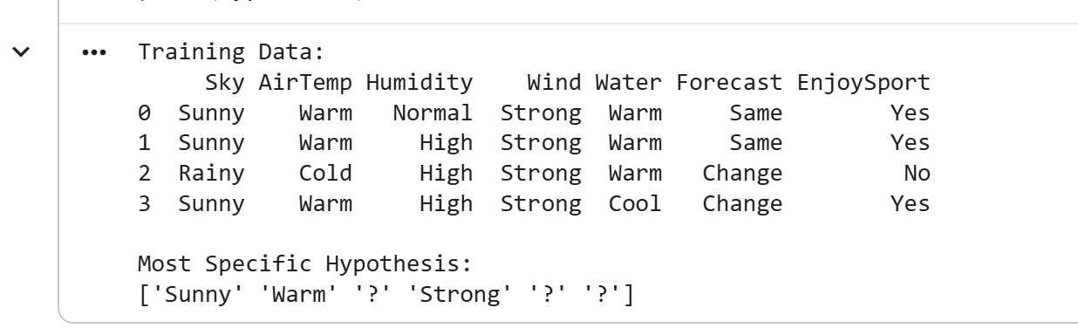

Experiment 2: Candidate Elimination Algorithm

AIM
To implement the Candidate Elimination Algorithm to determine the version space consisting of all hypotheses consistent with the given training data.
ALGORITHM
- Read the dataset.
- Initialize:
  - Specific Hypothesis (S)
  - General Hypothesis (G)
- For every training example:
  - If Positive
    - Update S.
    - Remove inconsistent hypotheses from G.
  - If Negative
    - Specialize G.
- Print final S and G.

PROGRAM

import pandas as pd

import numpy as np

# Create dataset
data = pd.DataFrame({
'Sky': ['Sunny', 'Sunny', 'Rainy', 'Sunny'],
'AirTemp': ['Warm', 'Warm', 'Cold', 'Warm'],
'Humidity': ['Normal', 'High', 'High', 'High'],
'Wind': ['Strong', 'Strong', 'Strong', 'Strong'],
'Water': ['Warm', 'Warm', 'Warm', 'Cool'],
'Forecast': ['Same', 'Same', 'Change', 'Change'],
'EnjoySport': ['Yes', 'Yes', 'No', 'Yes']
})

concepts = np.array(data.iloc[:, :-1])
target = np.array(data.iloc[:, -1])

def candidate_elimination(concepts, target):
specific = concepts[0].copy()
general = [['?' for _ in range(len(specific))] for _ in range(len(specific))]

for i, h in enumerate(concepts):
if target[i] == "Yes":
for x in range(len(specific)):
if h[x] != specific[x]:
specific[x] = '?'
general[x][x] = '?'
else:
for x in range(len(specific)):
if h[x] != specific[x]:
general[x][x] = specific[x]
else:
general[x][x] = '?'

general = [g for g in general if g != ['?'] * len(specific)]
return specific, general

s, g = candidate_elimination(concepts, target)

print("Specific Hypothesis:")
print(s)

print("\nGeneral Hypothesis:")
for hypothesis in g:
print(hypothesis)

Output
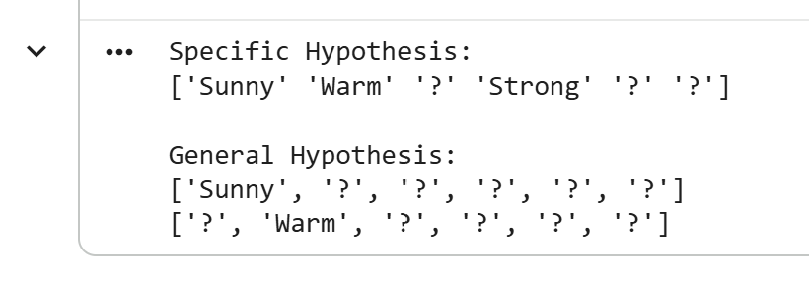

Experiment 3: ID3 Decision Tree

AIM
To implement the ID3 Decision Tree Algorithm and classify a new sample.
ALGORITHM
- Import dataset.
- Encode categorical values.
- Split into training and testing sets.
- Train Decision Tree using entropy criterion.
- Predict test data.
- Predict new sample.
- Display accuracy.
PROGRAM

import pandas as pd
from sklearn.preprocessing import LabelEncoder
from sklearn.tree import DecisionTreeClassifier
from sklearn.model_selection import train_test_split
from sklearn.metrics import accuracy_score

# Create dataset
data = pd.DataFrame({
'Outlook':['Sunny','Sunny','Overcast','Rain','Rain','Rain','Overcast','Sunny','Sunny','Rain','Sunny','Overcast','Overcast','Rain'],
'Temperature':['Hot','Hot','Hot','Mild','Cool','Cool','Cool','Mild','Cool','Mild','Mild','Mild','Hot','Mild'],
'Humidity':['High','High','High','High','Normal','Normal','Normal','High','Normal','Normal','Normal','High','Normal','High'],
'Wind':['Weak','Strong','Weak','Weak','Weak','Strong','Strong','Weak','Weak','Weak','Strong','Strong','Weak','Strong'],
'PlayTennis':['No','No','Yes','Yes','Yes','No','Yes','No','Yes','Yes','Yes','Yes','Yes','No']
})

print(data)

# Encode categorical values
encoder = LabelEncoder()
for col in data.columns:
data[col] = encoder.fit_transform(data[col])

X = data.iloc[:, :-1]
Y = data.iloc[:, -1]

X_train, X_test, Y_train, Y_test = train_test_split(
X, Y, test_size=0.3, random_state=1
)

model = DecisionTreeClassifier(criterion="entropy")
model.fit(X_train, Y_train)

pred = model.predict(X_test)

print("\nAccuracy:", accuracy_score(Y_test, pred))

# Example new sample: Outlook=Sunny, Temperature=Hot, Humidity=High, Wind=Weak
sample = [[2, 1, 0, 1]]
prediction = model.predict(sample)

print("Prediction:", prediction)

Output
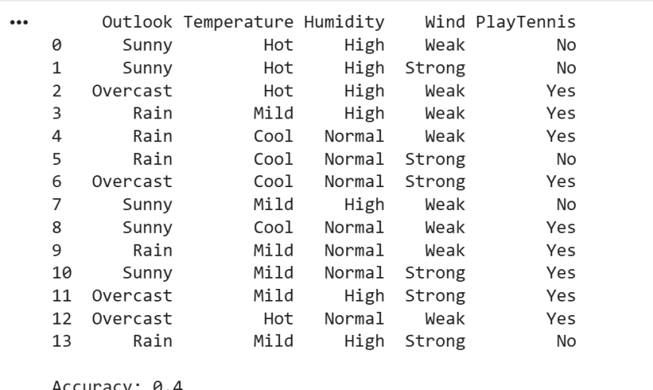

Experiment 4: Artificial Neural Network using Backpropagation

AIM
To implement an Artificial Neural Network using the Backpropagation Algorithm.
ALGORITHM
- Load dataset.
- Normalize data.
- Split training/testing.
- Create MLP classifier.
- Train network.
- Predict output.
- Display accuracy.
PROGRAM
from sklearn.datasets import load_iris
from sklearn.model_selection import train_test_split
from sklearn.preprocessing import StandardScaler
from sklearn.neural_network import MLPClassifier
from sklearn.metrics import accuracy_score

iris=load_iris()

X=iris.data
Y=iris.target

X_train,X_test,Y_train,Y_test=train_test_split(
X,Y,test_size=0.3,random_state=42)

scaler=StandardScaler()

X_train=scaler.fit_transform(X_train)
X_test=scaler.transform(X_test)

model=MLPClassifier(hidden_layer_sizes=(10,),
max_iter=1000,
random_state=1)

model.fit(X_train,Y_train)

pred=model.predict(X_test)

print("Accuracy =",accuracy_score(Y_test,pred))

Output
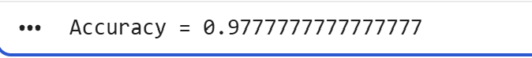

Experiment 5: K-Nearest Neighbours (KNN)

AIM
To implement the K-Nearest Neighbours (KNN) algorithm for classification.
ALGORITHM
- Load dataset.
- Split dataset.
- Standardize features.
- Train KNN classifier.
- Predict test data.
- Calculate confusion matrix and accuracy.
PROGRAM
from sklearn.datasets import load_iris
from sklearn.model_selection import train_test_split
from sklearn.preprocessing import StandardScaler
from sklearn.neighbors import KNeighborsClassifier
from sklearn.metrics import confusion_matrix,accuracy_score

iris=load_iris()

X=iris.data
Y=iris.target

X_train,X_test,Y_train,Y_test=train_test_split(
X,Y,test_size=0.3,random_state=42)

scaler=StandardScaler()

X_train=scaler.fit_transform(X_train)
X_test=scaler.transform(X_test)

classifier=KNeighborsClassifier(n_neighbors=3)

classifier.fit(X_train,Y_train)

pred=classifier.predict(X_test)

print("Confusion Matrix")

print(confusion_matrix(Y_test,pred))

print("\nAccuracy")

print(accuracy_score(Y_test,pred))

Output

